W-19
YEAR 10 SCIENCE (IEP)
PHYSICAL SCIENCE
TOPIC TEST
Name: Mark: $\frac{}{\text{10}}$

Part 1: Multiple Choice

Circle your choice for each question in the table below.

1. Speed is a measure of the rate:

(a) at which distance is covered.
(b) at which speed increases.
(c) of change in force.
(d) of change in acceleration.
sp
d
t
2. Belinda walks a total distance of 1200 metres to school each morning. If this trip takes her 800 seconds, her average speed
would be:

(a) 1.5 m/s.
(b) 0.67 m/s.
(c) 0 m/s.
(d) 960,000 m/s.

Part 2: Short Answer

1. Complete the following table on speed calculations. Use the triangle to help you.
(3 marks)
sp
d
t

Distance travelled | Time taken | Average speed
490 m | 35 s
195 m | 12 s
1600 m | 240

2. The map below shows Broome and Alice Springs. Use the map (look at it carefully) and its scale to work out the following.

(a) The distance between Broome Airport and Alice Springs airport on the road
(marked in blue). (1 mark)

(b) The distance between Broome Airport and Alice Springs airport on the road
(marked in grey). (1 mark)

(c) What is the scale on the map - how many kilometres does it show? (1 mark)

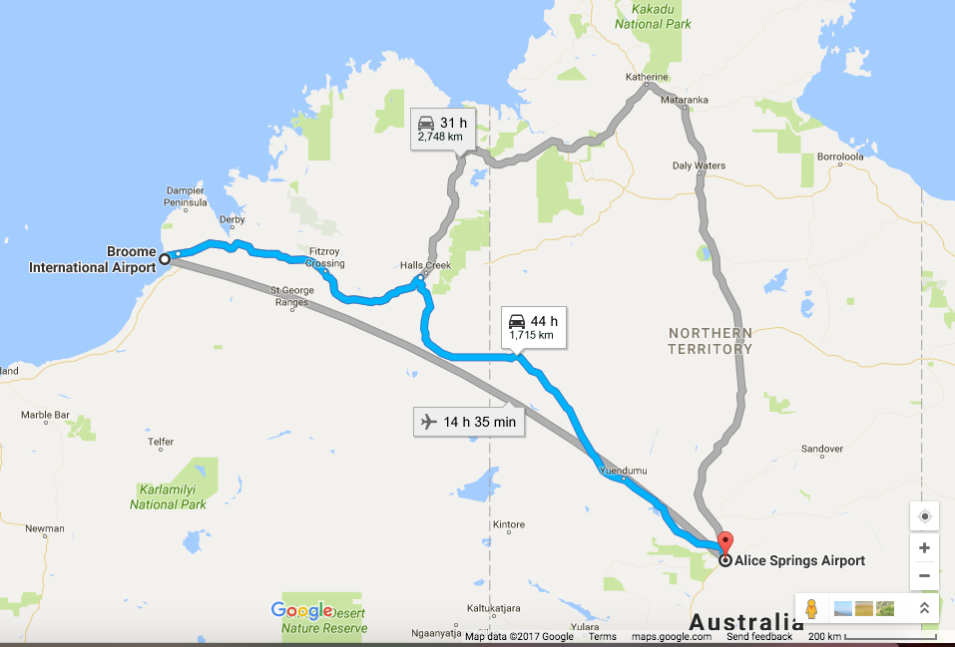

(d) Construct a set of compass points on Broome. Use this to determine the bearing in a straight line to Alice Springs. (2 marks)

